A Project Report

On

Brain Tumour Identification

Artificial Intelligence and Data Science

by

VIYYAPU V S D SAI VAMSI (2010030529)

under the supervision of

Dr. ARPITA GUPTA

Assistant Professor



Department of Computer Science and Engineering

K L University Hyderabad,

Aziz Nagar, Moinabad Road, Hyderabad – 500 075, Telangana, India.

March, 2022

**Declaration**

The Project Report entitled “Brain Tumour Identification” is a record of bonafide work of VIYYAPU V S D SAI VAMSI (2010030529), submitted as a requirement for the completion of the course **Artificial Intelligence and Data Science** in the Department of Computer Science and Engineering to the K L University, Hyderabad. The results embodied in this report have not been copied from any other Departments/universities/institutes.

VIYYAPU V S D SAI VAMSI - 2010030529

## Certificate

This is to certify that the Project Report entitled “Brain Tumour Identification” is being submitted by VIYYAPU V S D SAI VAMSI(2010030529) as a requirement for the completion of the course **Artificial Intelligence and Data Science** in the Department of Computer Science and Engineering, K L University, Hyderabad is a record of bonafide work carried out under our guidance and supervision.

The results embodied in this report have not been copied from any other departments/universities/institutes.

## Signature of the Supervisor

## Signature of the HOD Signature of the Examiner

**ACKNOWLEDGEMENT**

First and foremost, we thank the lord almighty for all his grace & mercy showered upon us, for completing this project successfully.

We take a grateful opportunity to thank our beloved Founder and Chairman who has given constant encouragement during our course and motivated us to do this project. We are grateful to our Principal **Dr. L. Koteswara Rao** who has been constantly bearing the torch for all the curricular activities undertaken by us.

We pay our grateful acknowledgment & sincere thanks to our Head of the Department **Dr. Chiranjeevi Manike** for his exemplary guidance, monitoring, and constant encouragement throughout the course of the project. We thank **Dr. Arpita Gupta Ma’am** of our department who has supported us throughout this project holding the position of supervisor.

We wholeheartedly thank all the teaching and non-teaching staff of our department without whom we won’t have made this project a reality. We would like to extend our sincere thanks, especially to our parents, our family members, and friends who have supported us to make this project a grand success.

## ABSTRACT

blastomas (both low and high grade) pictured in MR images. By their very nature, these tumors can appear anywhere in the brain and have almost any kind of shape, size, and contrast

These reasons motivate our exploration of a machine learning solution that exploits a flexible, high capacity DNN while being extremely efficient. Here, we give a description of different model choices that we've found to be necessary for obtaining competitive performance. We explore in particular different architectures based on Convolutional Neural Networks (CNN), i.e. DNNs specifically adapted to image data.

We present a novel CNN architecture which differs from those traditionally used in computer vision. Our CNN exploits both local features as well as more global contextual features simultaneously.

**TABLE OF CONTENTS**

|  |  |
| --- | --- |
| 1 | Acknowledgement |
| 2 | Abstract |
| 3 | Introduction |
| 4 | Literature Survey |
| 5 | Hardware & Software requirements |
| 6 | Proposed System |
| 7 | Dataset |
| 8 | Implementation |
| 9 | Output Results |
| 10 | Discussion |
| 11 | Conclusion |
| 12 | References |

**INTRODUCTION**

MRI Imaging plays an important role in brain tumour for analysis, diagnosis, and treatment planning. It’s helpful to doctors for determining the previous steps of brain tumour.

Brain tumour detections are using MRI images is a challenging task, because of the complex structure of the brain.

The brain tumour is an abnormal growth of cells of the brain.

MRI images offer better difference concerns of various soft tissues of the human body.

After getting the brain scanning images the machine have to identify whether the person brain is fine or has a tumour in his brain

Using ML we can also identify at what stage the tumour is spread

 Machine learning and deep learning techniques have gained significance among researchers in medical fields, especially convolutional neural networks (CNN), due to their ability to analyse large amounts of complex image data and perform classification.

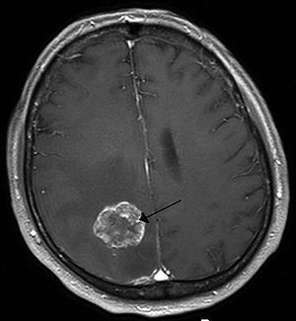

**Literature Survey**

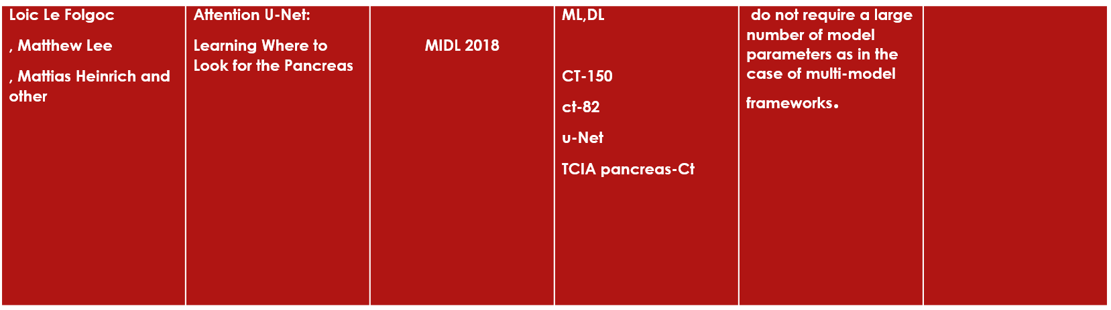

**Page.1**

|  |  |  |  |  |  |
| --- | --- | --- | --- | --- | --- |
| **Mohammad Havaeia,1, Axel Davyb**  **, David Warde-Farleyc**  **, Antoine Biardc,d, Aaron Courvillec**  **, Yoshua Bengioc**  **, Chris Palc,e**  **,**  **Pierre-Marc Jodoina**  **, Hugo Larochellea** | **Brain Tumor Segmentation with Deep Neural Networks✩** | **In the United States alone, it is estimated that 23,000 new**  **cases of brain cancer will be diagnosed in 2015** | **Dnn and CNN**    **FCascadeCNN*, TwoPathCNN* and LocalCascadeCNN* BRATS-2013** | **. While some tumors such as meningiomas can be easily segmented**  **. . By their very nature, these tumors can appear anywhere in the brain and have almost any kind of shape, size, and contrast** | **we could not report complete and fair experiments for it at the time of submitting this manuscript.**  **. filter response is not computed for pixel positions that are less than bN/2c pixels away from the image border** |

**Page.2**

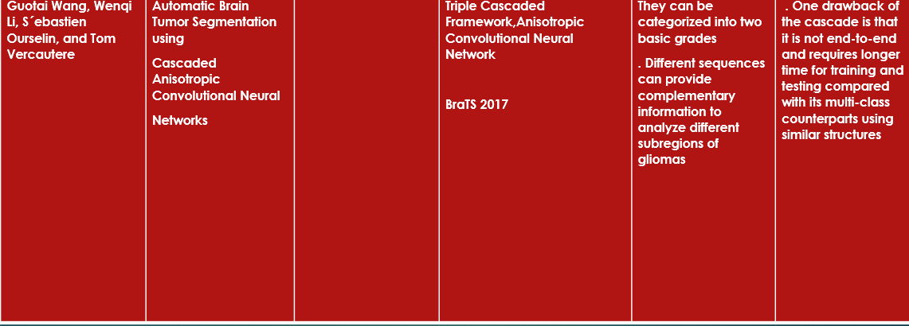

**Page.3**

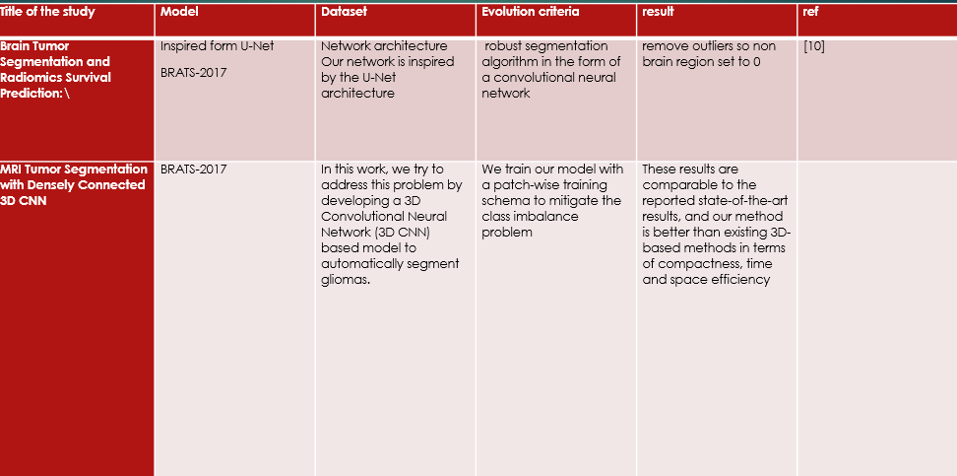

**Page.4**

**HARDWARE REQUIREMENTS & SOFTWARE REQUIREMENTS**

## Hardware requirements:

## Processor - Intel(R) Core(TM) i5 -8565U CPU @ 1.80GHz 1.99 GHz

## RAM – 16.0 GB (15.8 GB usable)

## Hard disk – 476.61 GB

## Keyboard – 122 keys

## Software requirements:

## Operating system – Microsoft

## PyCharm

## python

TensorFlow

**PROPOSED SYSTEM**

The proposed system is created by deep learning using cnn model the main this thing in the proposed system is the model is having less accuracy the reason behing this is his data he is having less data of size 16mb the model and the no of frames created are less due to which the brain images are getting less frames so the model can not identify small tumors in the brain this is the main draw back in this

**DATASET**

Brain Tumors are complex. There are a lot of abnormalities in the sizes and location of the brain tumor(s). This makes it really difficult for complete understanding of the nature of the tumor. Also, a professional Neurosurgeon is required for MRI analysis. Often times in developing countries the lack of skillful doctors and lack of knowledge about tumors makes it really challenging and time-consuming to generate reports from MRI’. So an automated system on Cloud can solve this problem.

The majour data sets we used are yes and no

The yes data set contain all the tumor brain images

The no data set contain all the non tumor brain images

We are having more thank 20mb data

[Brain MRI Images for Brain Tumor Detection | Kaggle](https://www.kaggle.com/datasets/navoneel/brain-mri-images-for-brain-tumor-detection)

**IMPLEMENATION**

to implement this project first we have to import some lib TensorFlow ,images, NumPy, train_test_split, keras etc..

if we have to use TensorFlow first we have to install Nvidia

after importing this lib we have to take our dataset and create a list this list will be passed to our main program where the given data is converted into 0,1 in this method we pass our yes data and give some value 1 and we pass our second data and give some value 0 and we display output this output is known as preprocess

next we pass our data to training part here we train our data in this process our model understands which one is having tumor in it

we use normalize lib this normalizes the data this is because out data is having different frames our model takes more time to enolized every image with different frames so we used this lib so that we can give same frame value for all data

next we rain out data

we create models

last we pass this output data which is in encrypted form is stored in BrainTumourcategorical10Epochs.h5 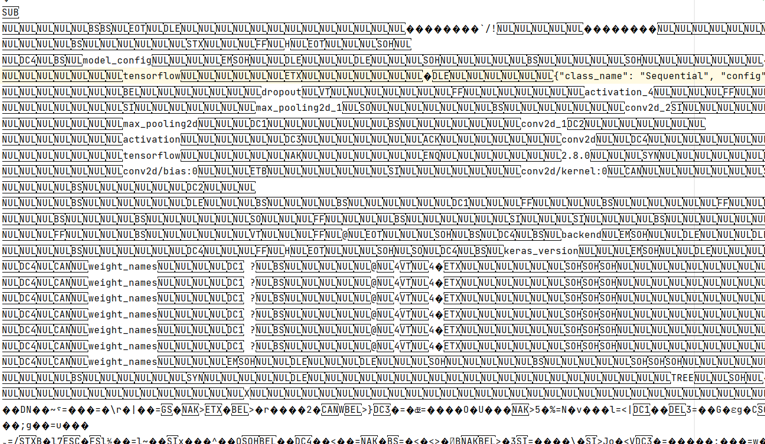

we send this text file to our main logic code which is having flask frame work

we will pass our model data in this and take input this input is a path of the brain image we pass this into flask frame work and identify the image is have tumor or not

Flow diagram

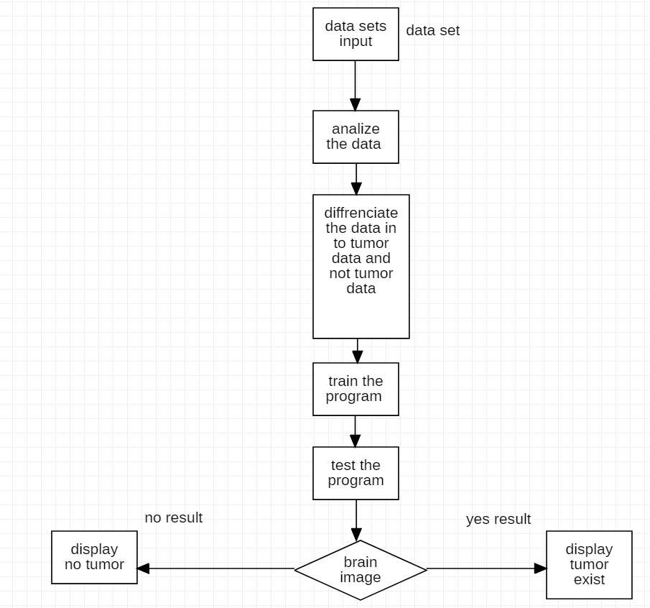

**OUTPUT RESULTS**

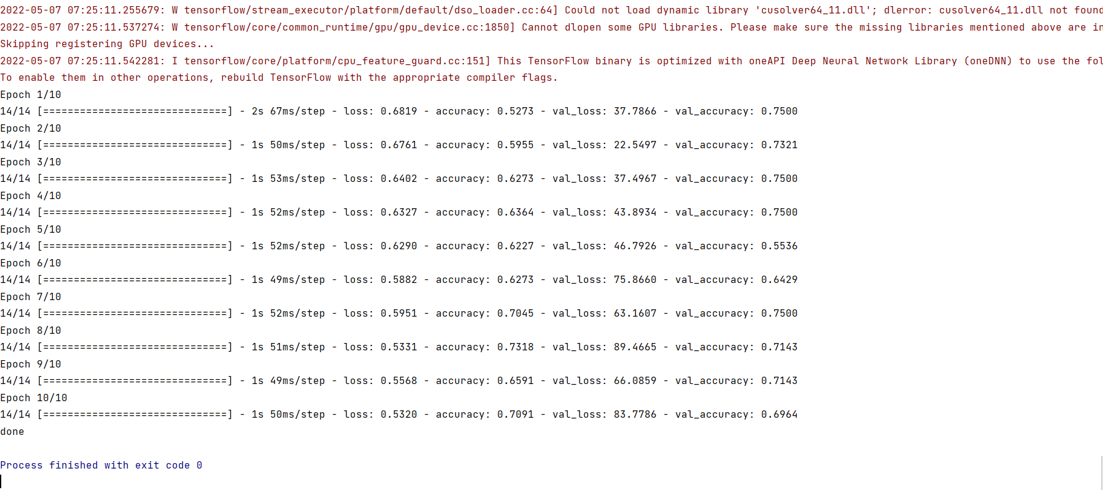

Our model is successfully executed

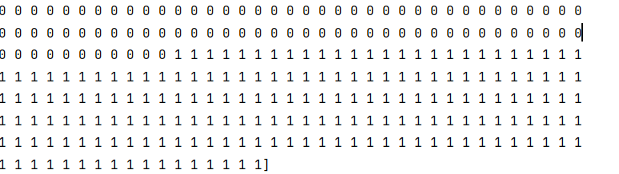Pre process



Tumor dose not exist



**Tumor exist**

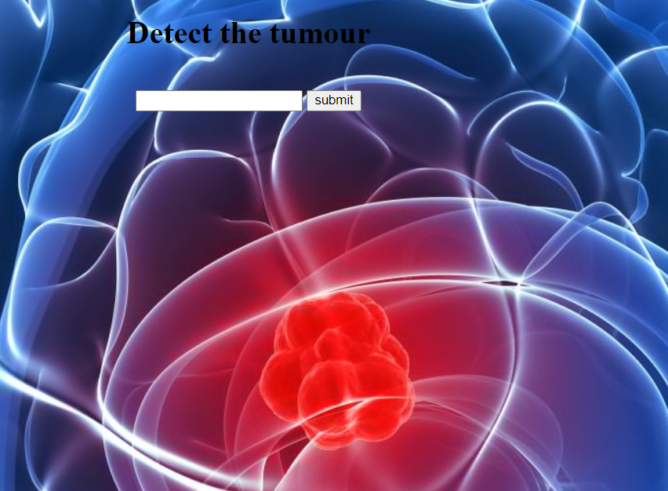

Website using flask

**Discussion**

In brain tumor detection to identify we use machine learning to implement this we use TensorFlow in python using this lib we identify

We use machine language because it divide the image into frames and we can also decide how many no of frames should be each frame identify its part weather the part have any tumor cells In it or not

Give the output according to it

**CONCLUSION**

* This technic is so easy whether the person suffering or not
* By using this technic we can understand the size of a tumour
* This is the fast technique

**REFERENCES**

28 Feb 2018  ·  [Fabian Isensee](https://paperswithcode.com/author/fabian-isensee), [Philipp Kickingereder](https://paperswithcode.com/author/philipp-kickingereder), [Wolfgang Wick](https://paperswithcode.com/author/wolfgang-wick), [Martin Bendszus](https://paperswithcode.com/author/martin-bendszus), [Klaus H. Maier-Hein](https://paperswithcode.com/author/klaus-h-maier-hein)

18 Jan 2018  ·  [Lele Chen](https://paperswithcode.com/author/lele-chen), [Yue Wu](https://paperswithcode.com/author/yue-wu), [Adora M. DSouza](https://paperswithcode.com/author/adora-m-dsouza), [Anas Z. Abidin](https://paperswithcode.com/author/anas-z-abidin), [Axel Wismuller](https://paperswithcode.com/author/axel-wismuller), [Chenliang Xu](https://paperswithcode.com/author/chenliang-xu)

1 Sep 2017  ·  [Guotai Wang](https://paperswithcode.com/author/guotai-wang), [Wenqi Li](https://paperswithcode.com/author/wenqi-li), [Sebastien Ourselin](https://paperswithcode.com/author/sebastien-ourselin), [Tom Vercauteren](https://paperswithcode.com/author/tom-vercauteren)

[Brain MRI Images for Brain Tumor Detection | Kaggle](https://www.kaggle.com/datasets/navoneel/brain-mri-images-for-brain-tumor-detection)